**EXPERIMENT NO:-5**

**AIM:**

To familiarize with aggregate functions

**PROCEDURE:**

1. List total loan

SELECT SUM(AMOUNT) FROM BORROW;

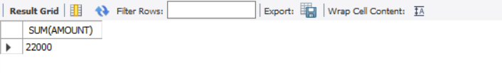

1. List total deposit

SELECT SUM(AMOUNT) FROM DEPOSITE;

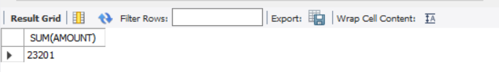

1. List total loan taken from KAROLBAGH branch

SELECT MAX(AMOUNT) FROM BORROW WHERE BNAME="KAROLBAGH";

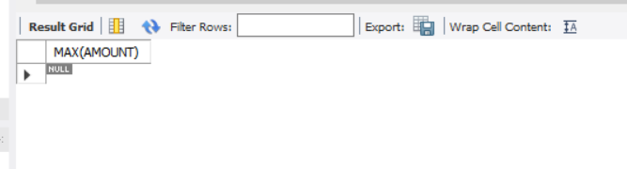

1. List total deposit of customers having account date later than 1-Mar-95

SELECT SUM(AMOUNT) FROM DEPOSITE WHERE ADATE>'1995-03-01';

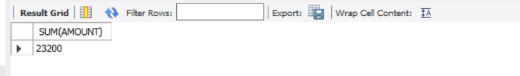

1. List total deposit of customers living in city NAGPUR

SELECT SUM(D1.AMOUNT) FROM DEPOSITE D1,CUSTOMER C1 WHERE C1.CITY="NAGPUR" AND C1.CNAME=D1.CNAME;

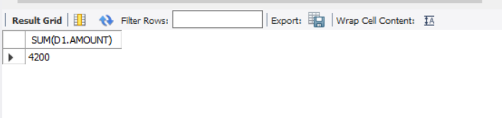

1. List maximum deposit of customer living in Bombay

SELECT MAX(D1.AMOUNT) FROM DEPOSITE D1,CUSTOMER C1 WHERE C1.CITY="BOMBAY" AND C1.CNAME=D1.CNAME;

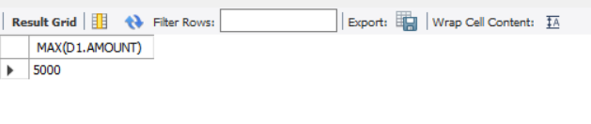

1. List total deposit of customer having branch in BOMBAY

SELECT SUM(AMOUNT) FROM DEPOSITE,BRANCH WHERE CITY="BOMBAY";

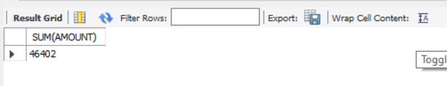

1. Count total number of branch cities

SELECT COUNT(DISTINCT(CITY)) FROM BRANCH;

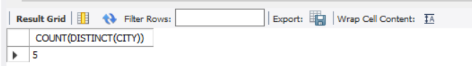

1. Count total number of customers cities

SELECT COUNT(CITY) FROM CUSTOMER;

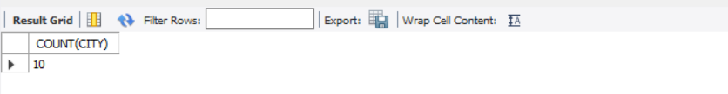

1. Give branch names and branch wise deposit

SELECT BNAME,SUM(AMOUNT) FROM DEPOSITE GROUP BY BNAME;

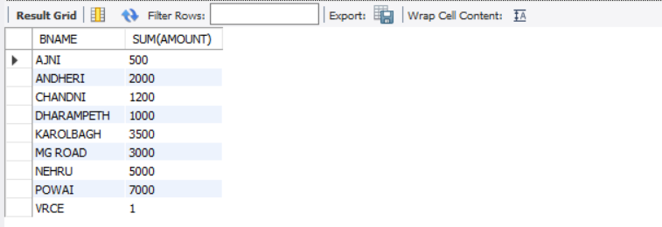

1. Give city wise name and branch wise deposit

SELECT C1.CITY,SUM(D1.AMOUNT) FROM CUSTOMER C1,DEPOSITE D1 WHERE D1.CNAME=C1.CNAME GROUP BY C1.CITY;

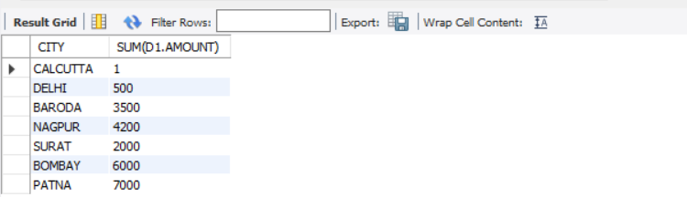

1. Give the branch wise loan of customer living in NAGPUR

SELECT BNAME,SUM(AMOUNT) FROM BORROW,CUSTOMER WHERE CITY="NAGPUR" GROUP BY BNAME;

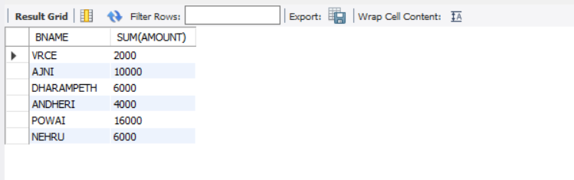

1. Count total number of customers

SELECT COUNT(CNAME) FROM CUSTOMER;

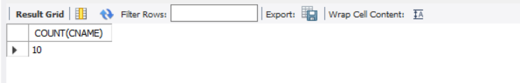

1. Count total number of depositors branch wise

SELECT BNAME,count(*) FROM DEPOSITE,CUSTOMER WHERE DEPOSITE.CNAME=CUSTOMER.CNAME GROUP BY BNAME;

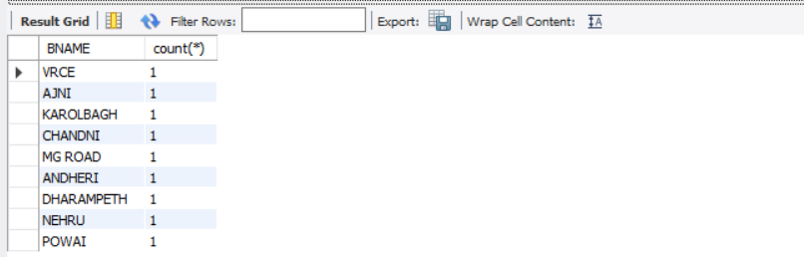

1. Give maximum loan from branch VRCE

SELECT MAX(AMOUNT) FROM BORROW WHERE BNAME="VRCE";

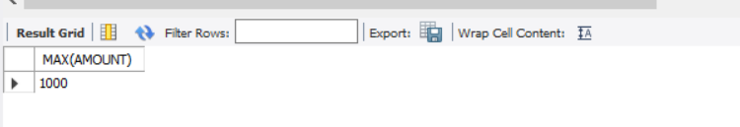

1. Give the number of customers who are depositors as well as borrowers

SELECT COUNT(*) FROM (SELECT CNAME FROM DEPOSITE INTERSECT SELECT CNAME FROM BORROW) AS A;

